1. Exercise Asking Questions About the Data

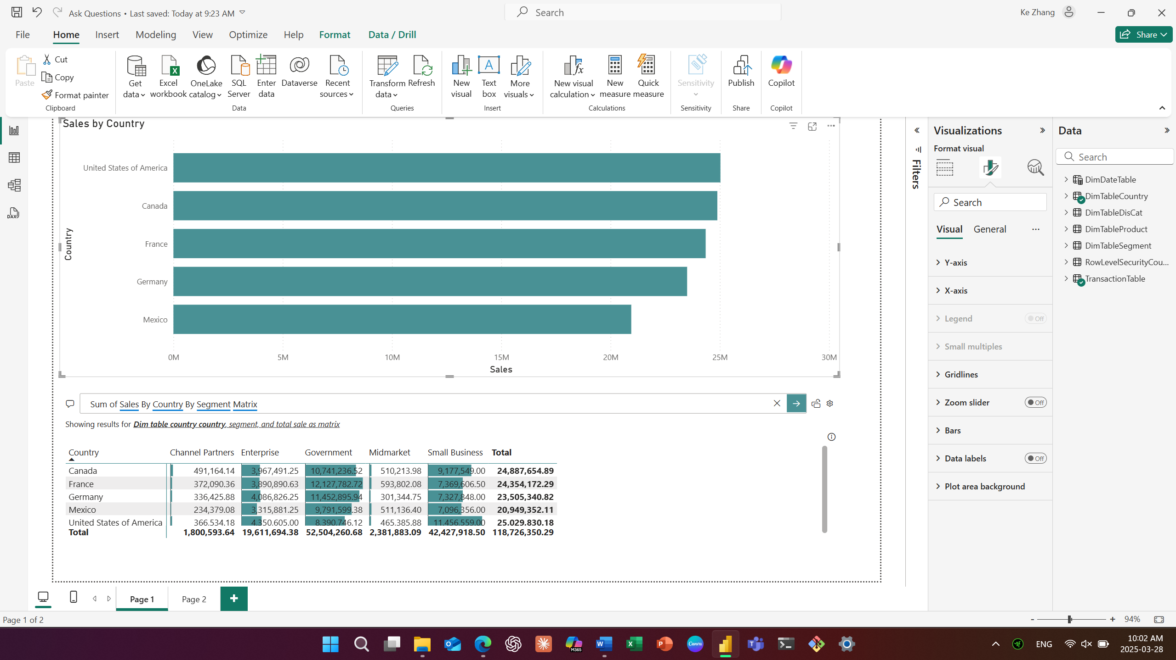

1. Exercise Publish Report to Power BI Service

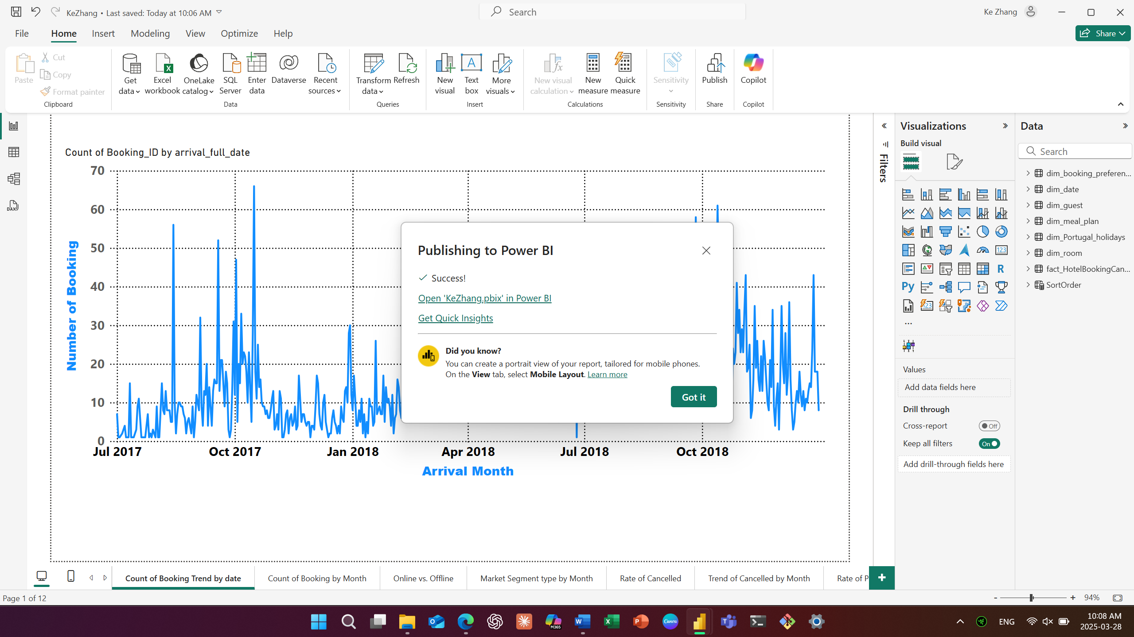

3.1 Exercise Set up Row-Level Security

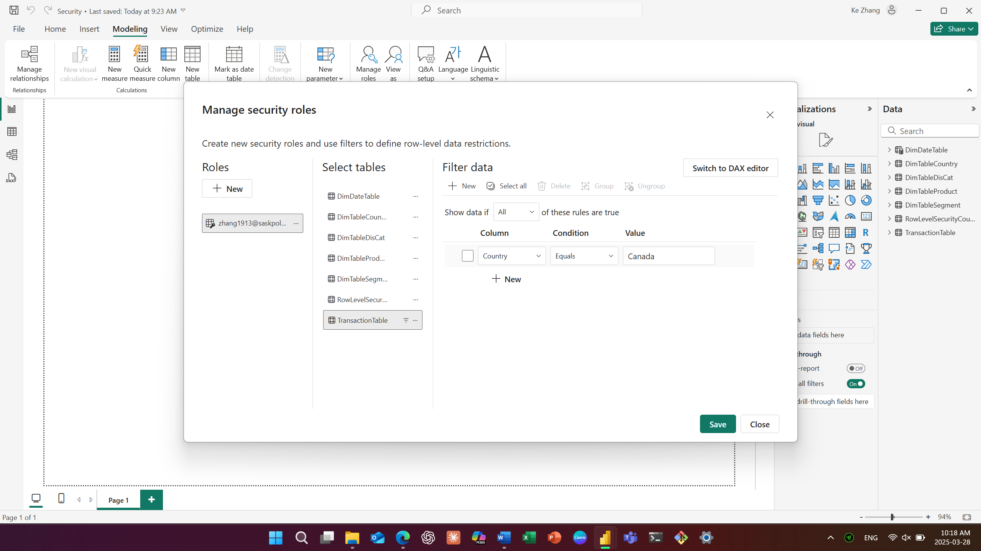

* 1. Exercise Set up Row-Level Security

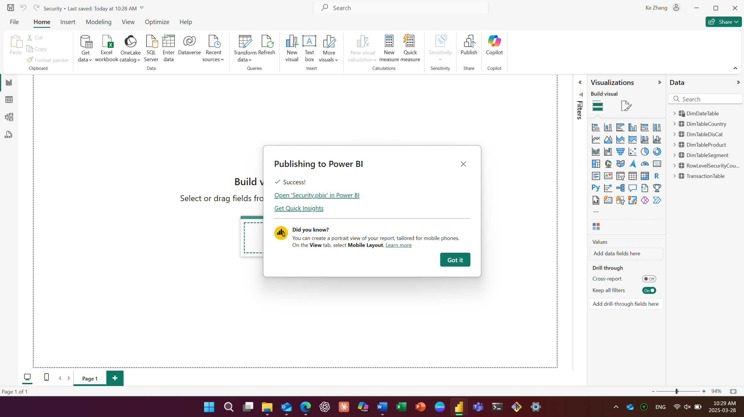

1. Exercise How to test what another would see on a Report with Row_Level security

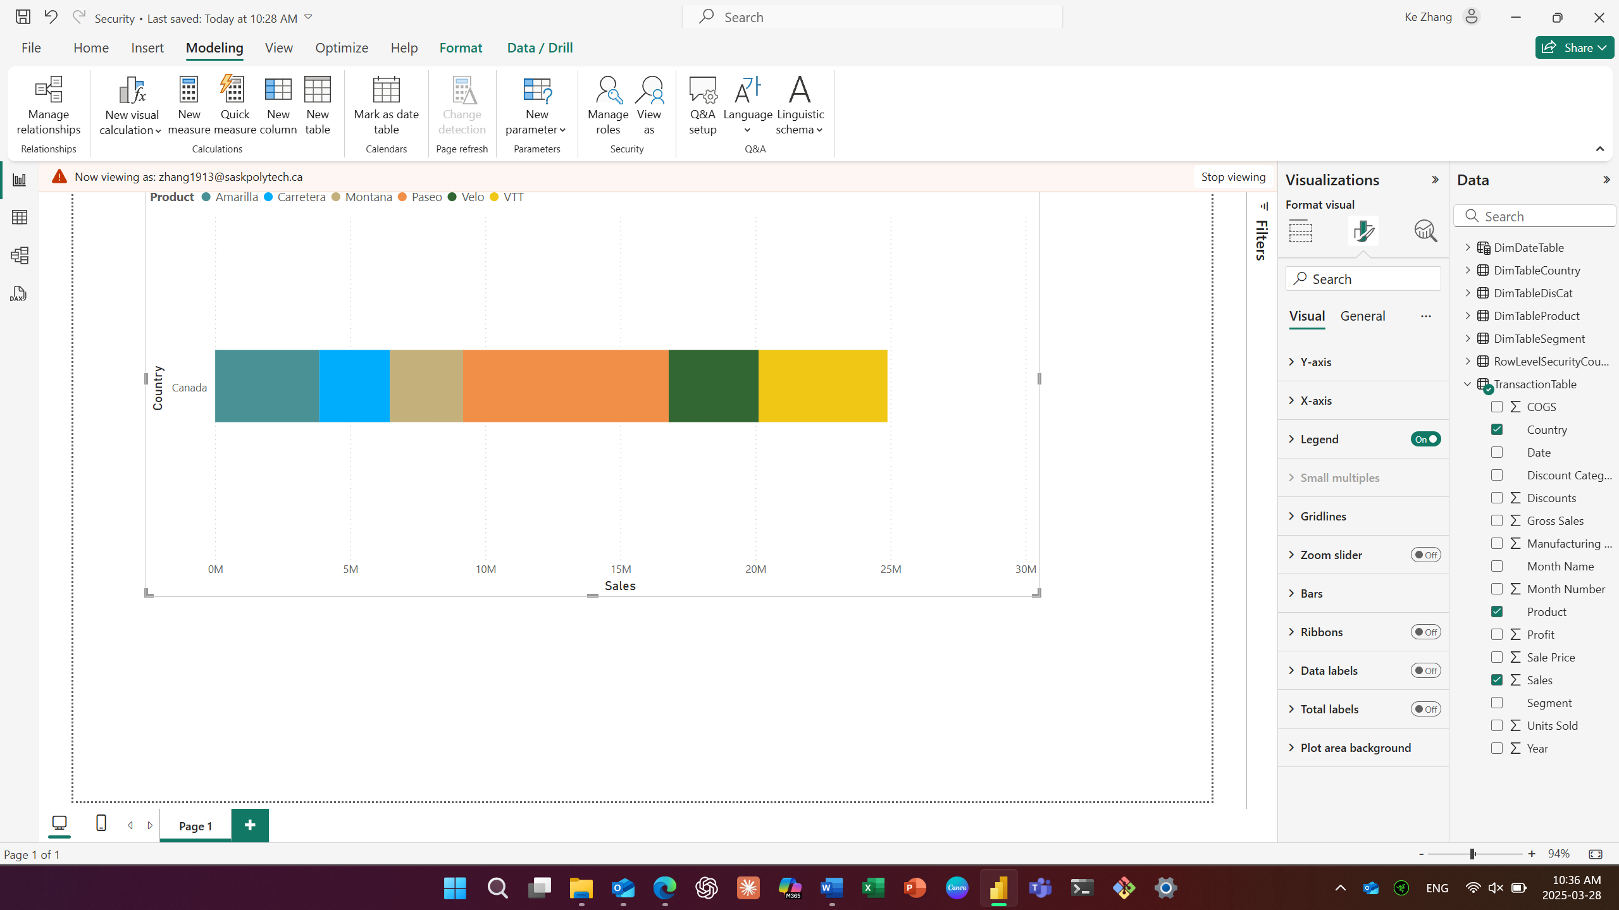

5.1 Exercise Add Tiles to a Dashboard

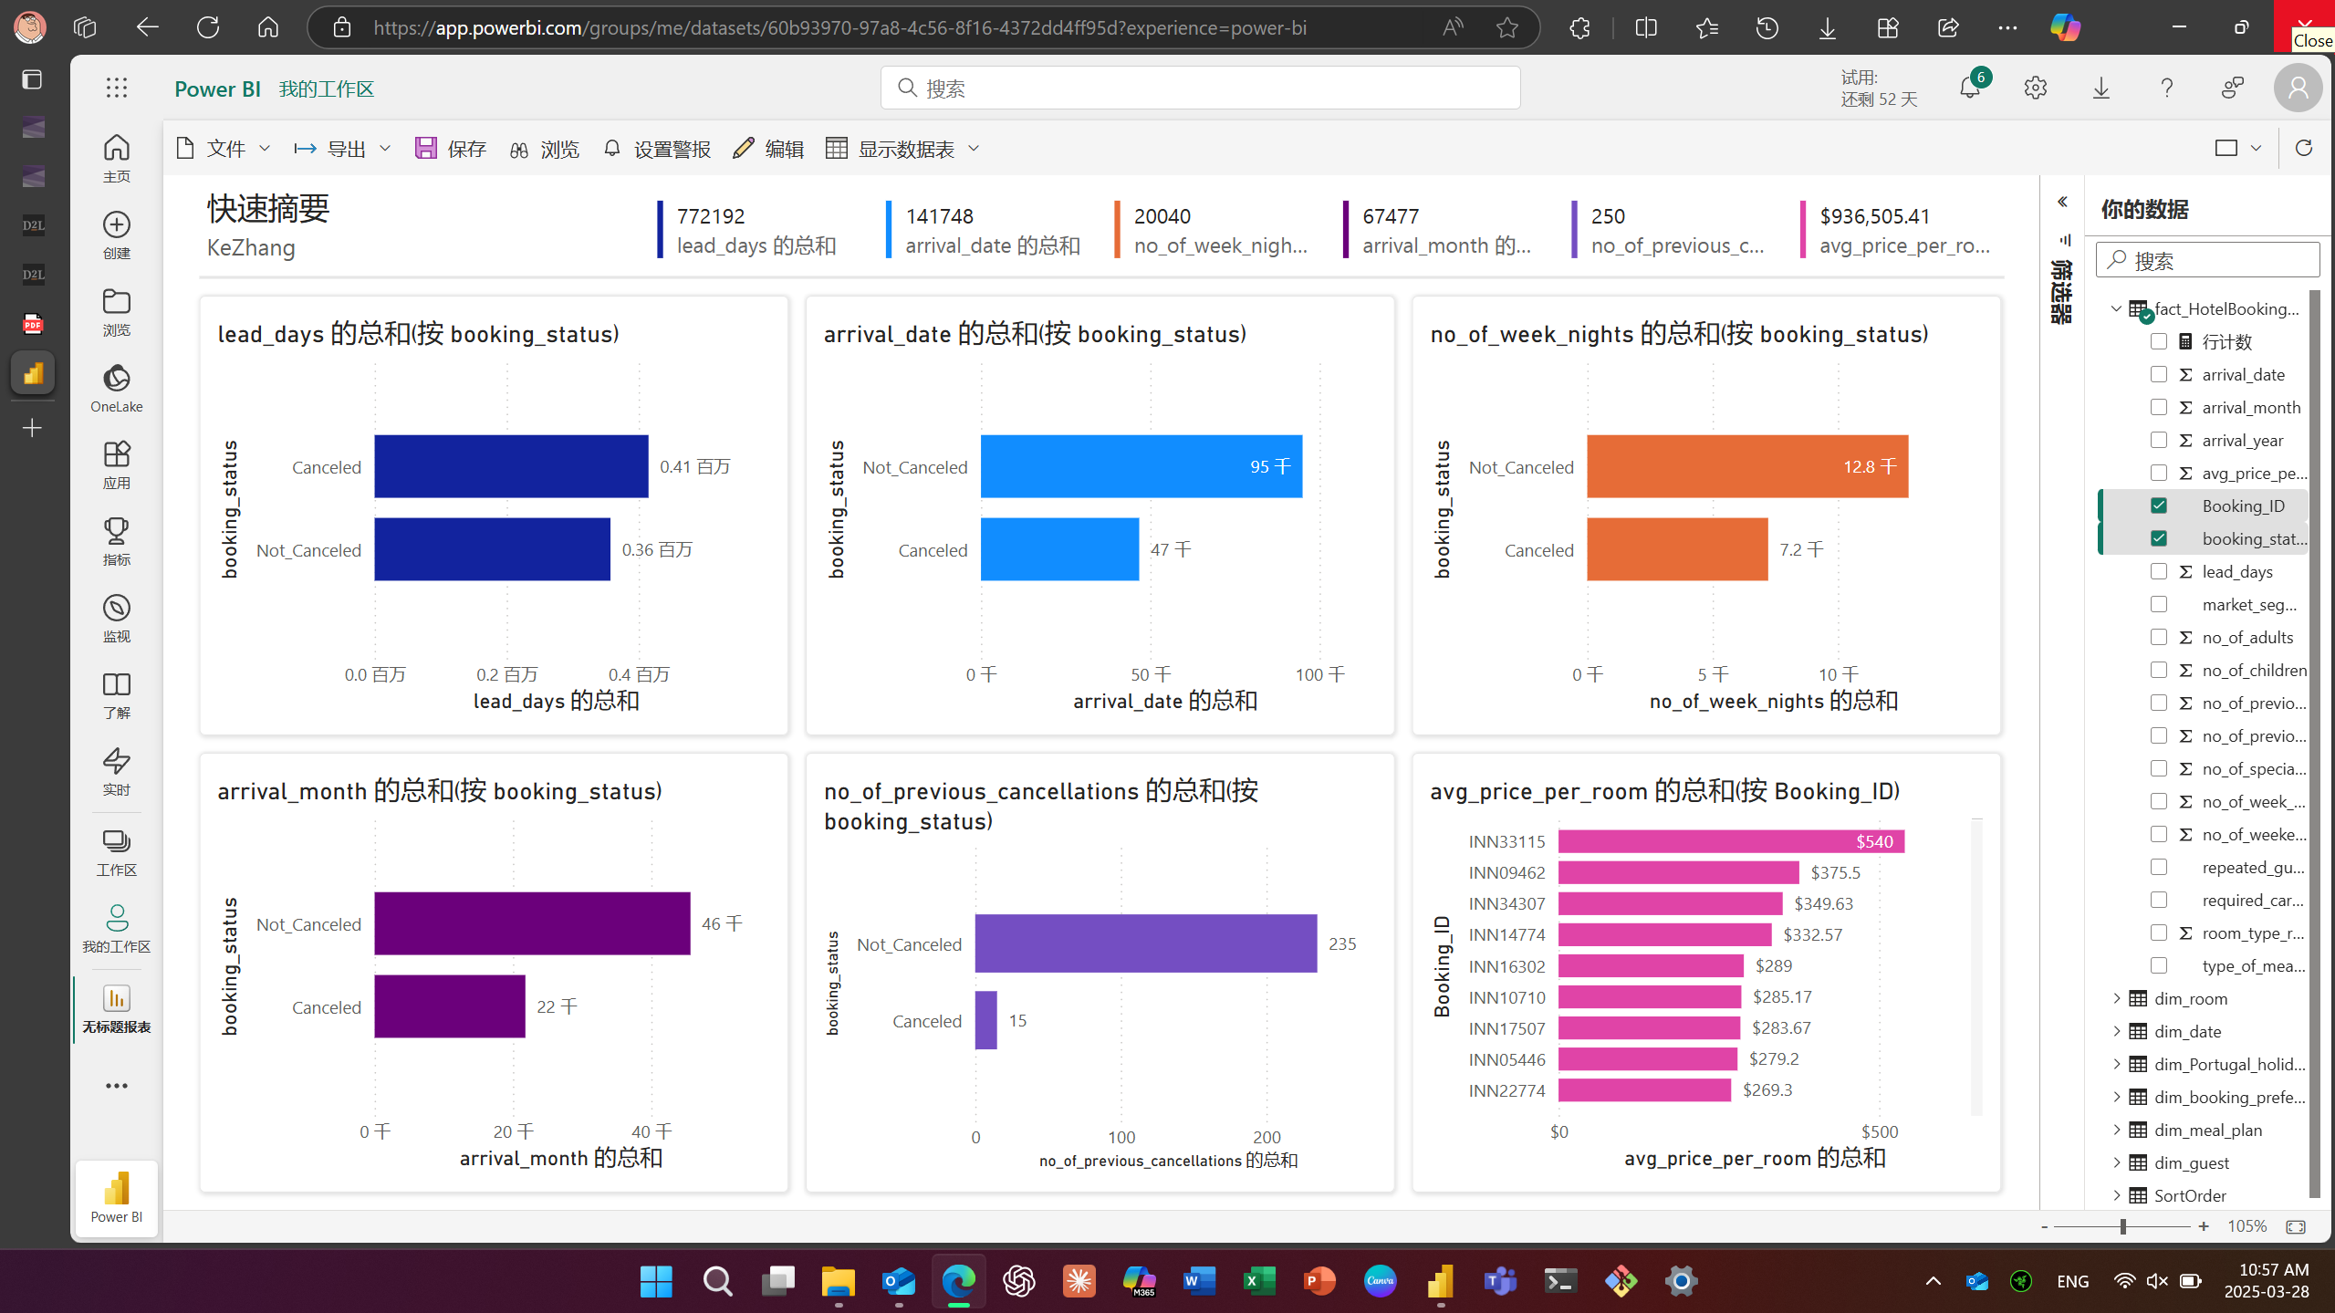

* 1. Exercise Add Tiles to a Dashboard

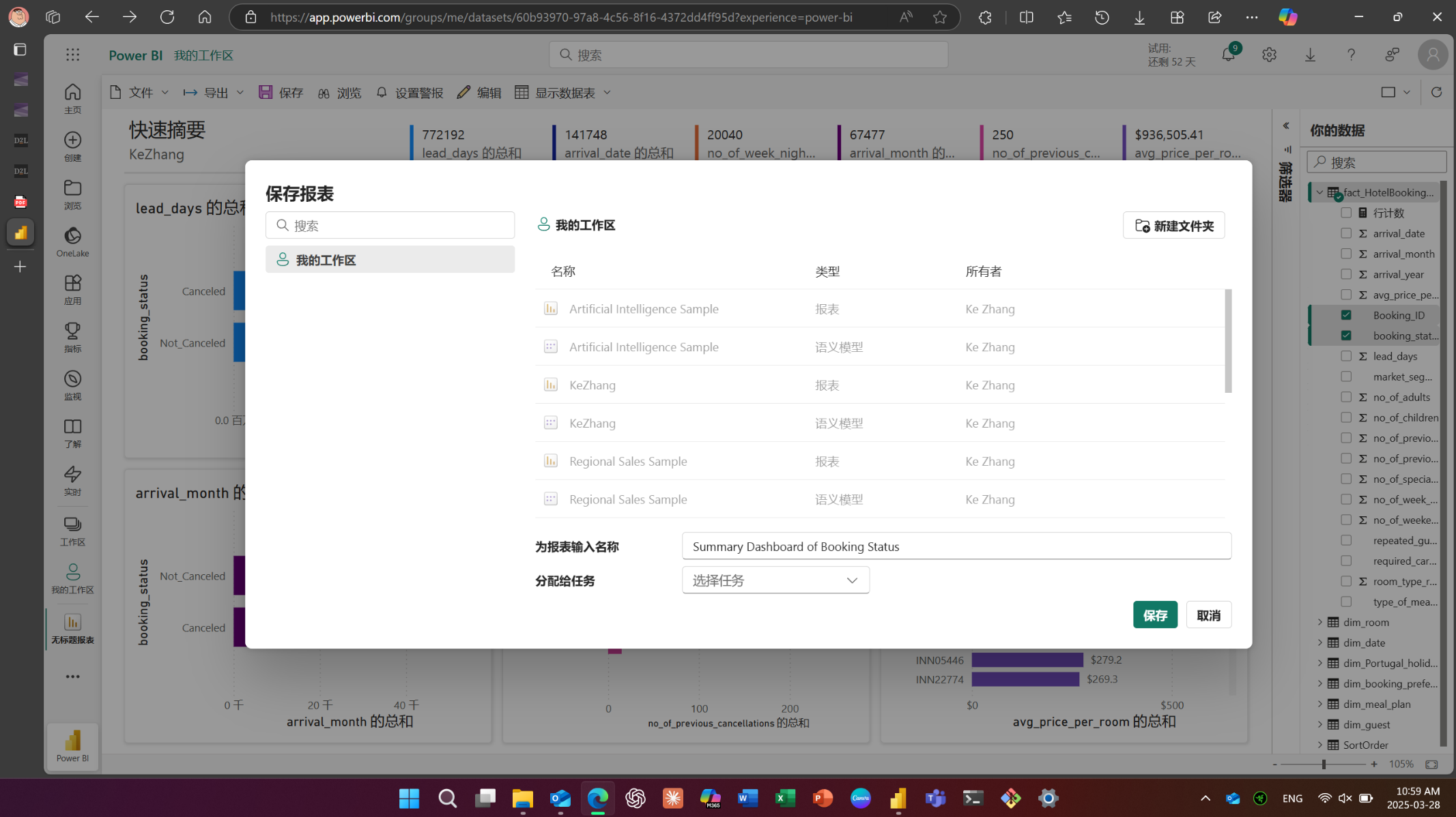

1. Exercise Share a Dashboard

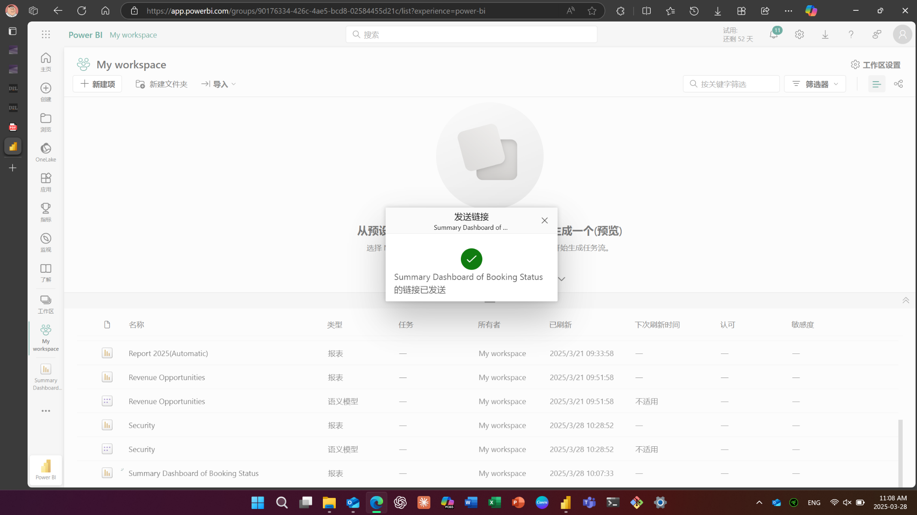

1. Exercise How can I restrict the users with whom I share a link

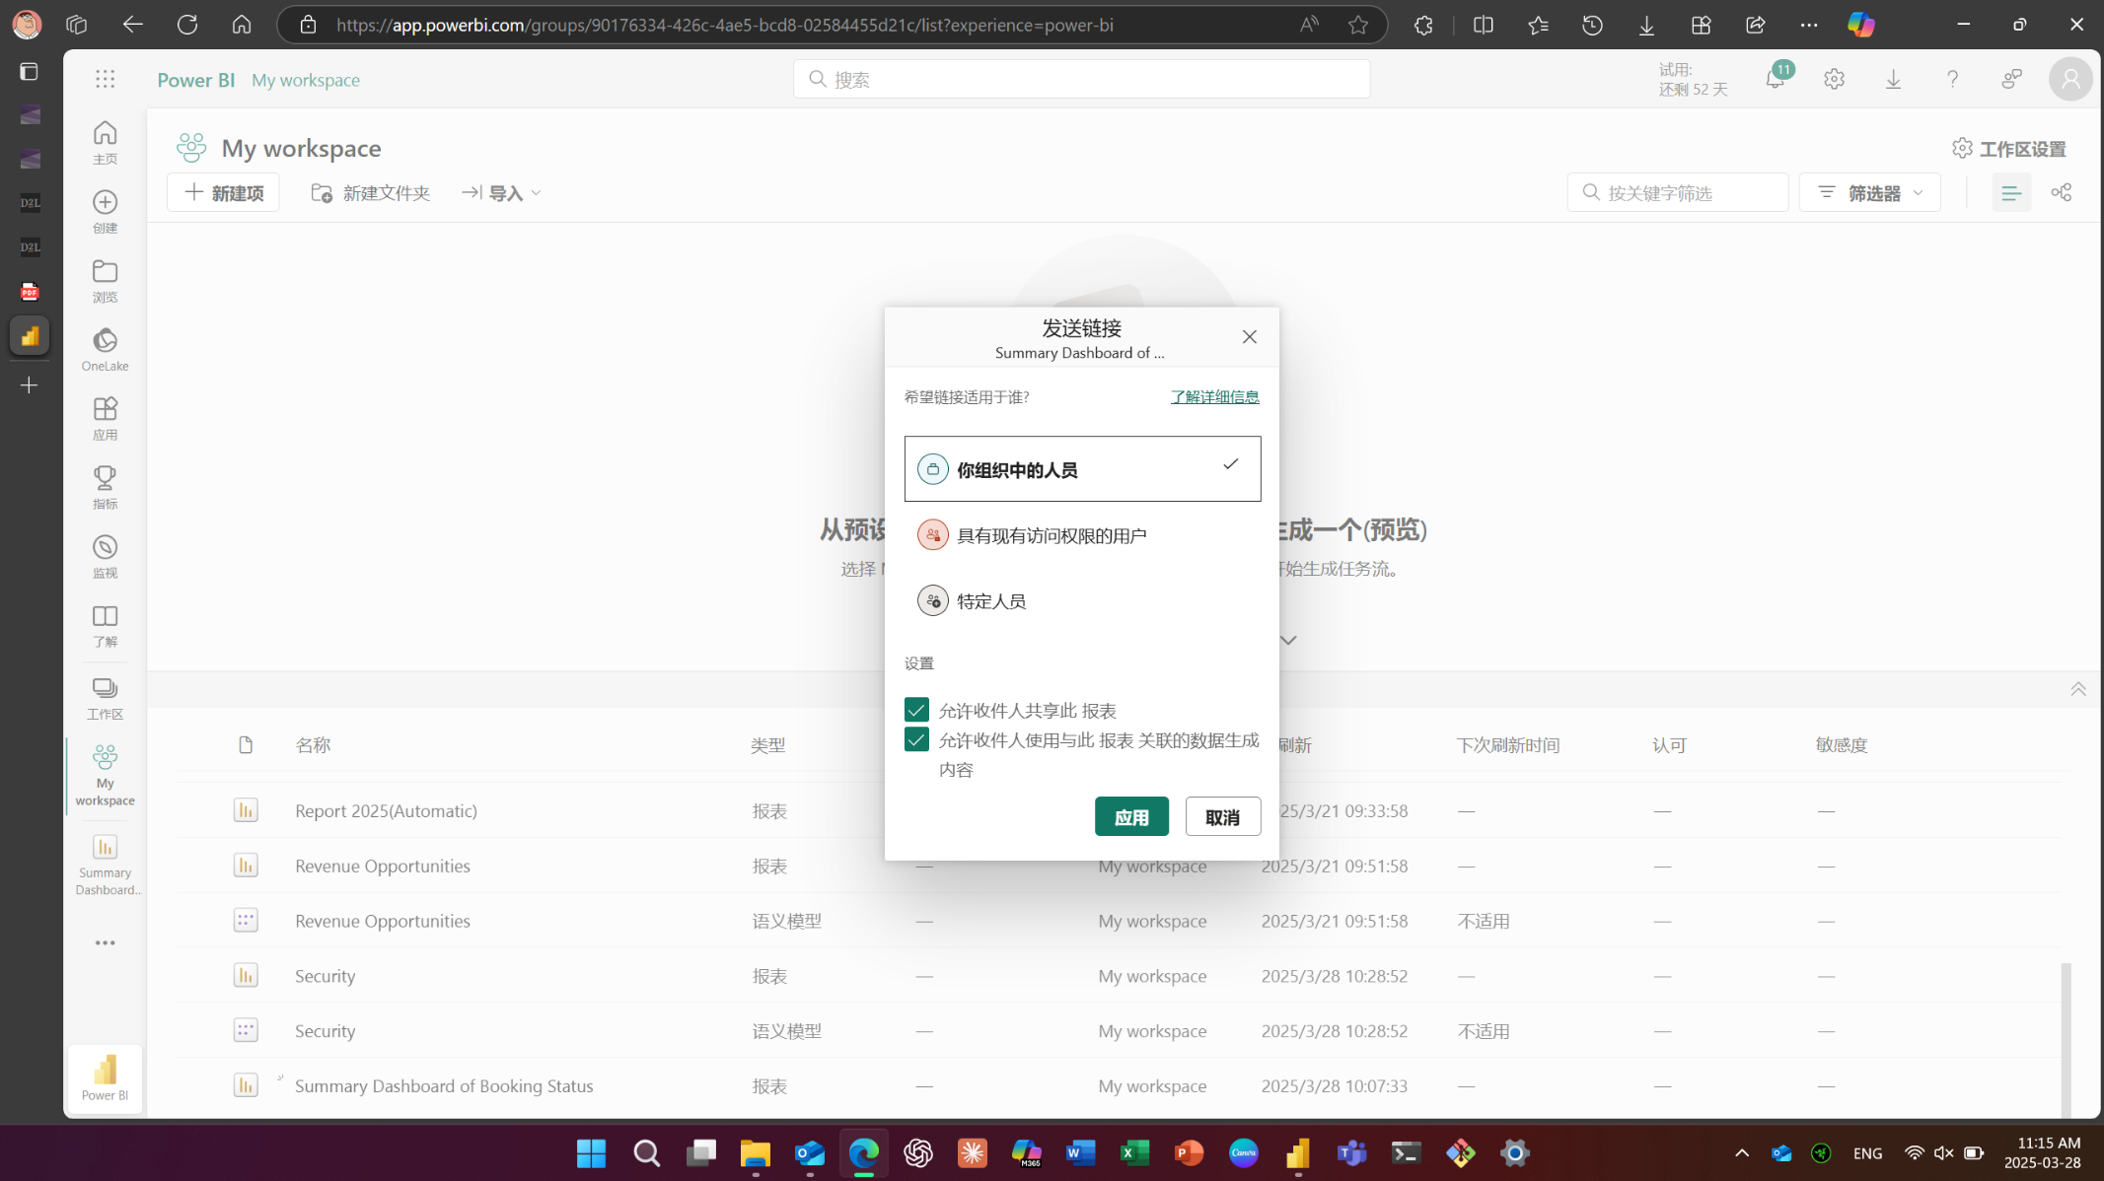

1. Gateway Connection setup

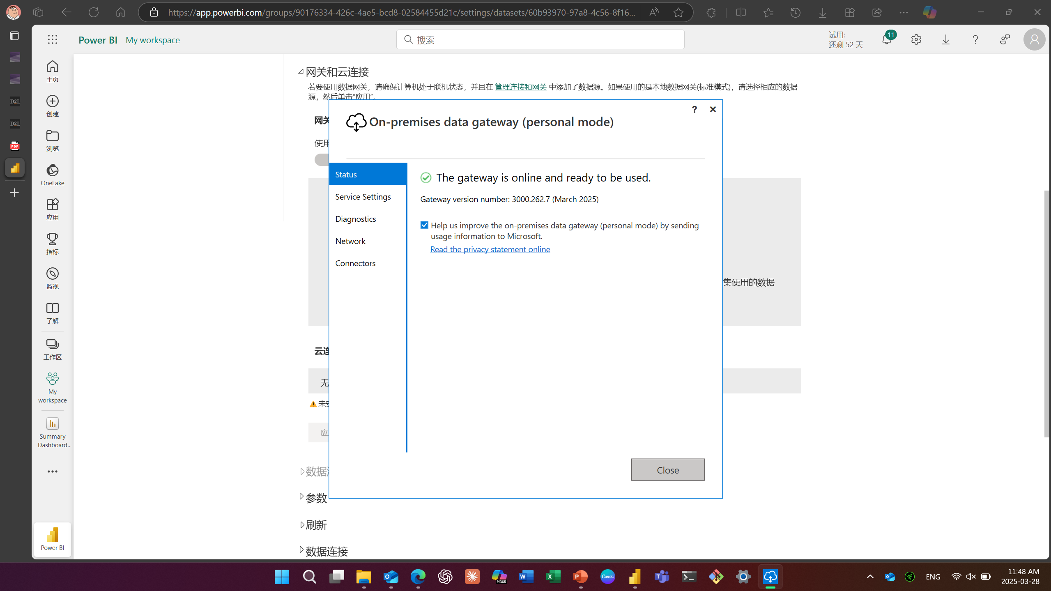

1. Exercise Schedule Data Refreshes

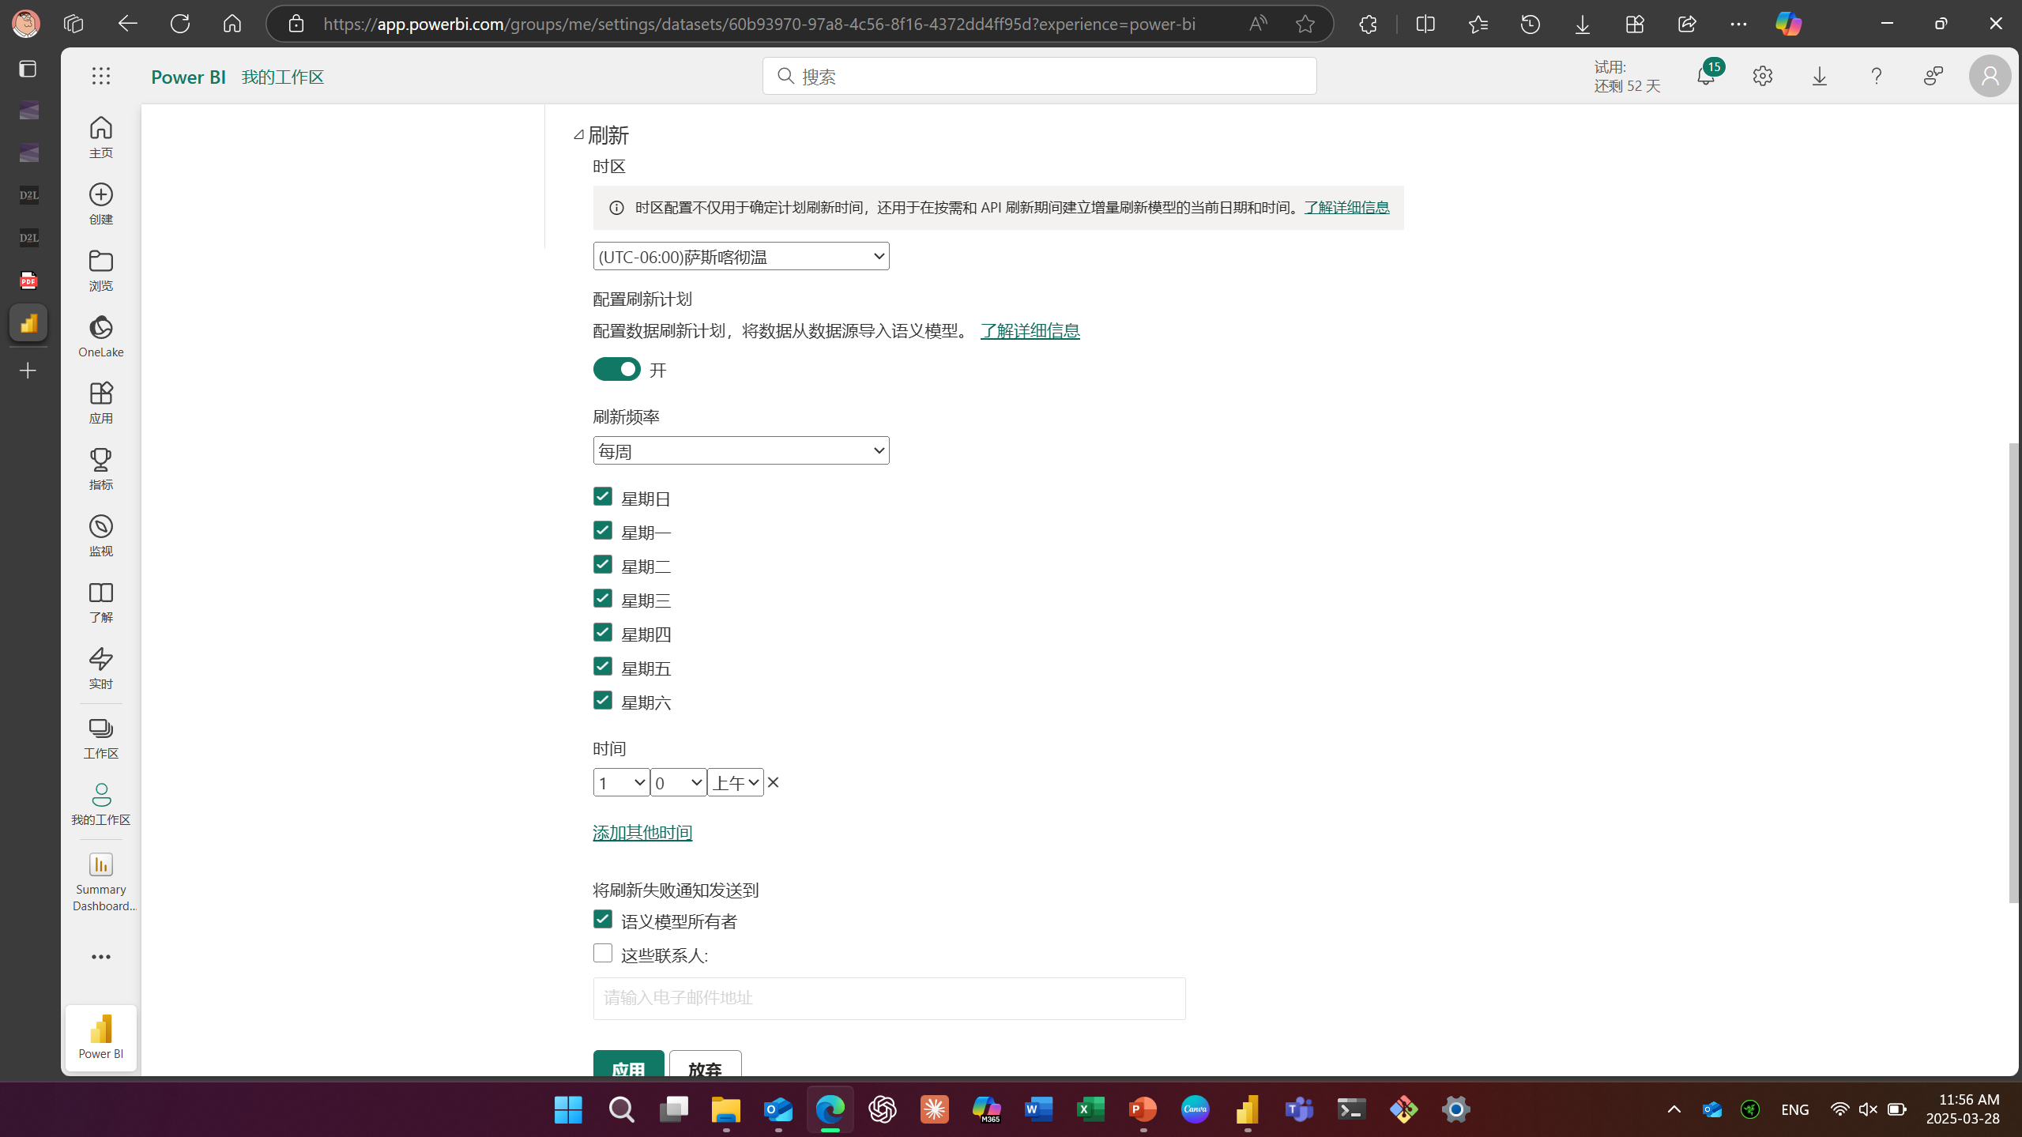

1. Exercise Publish a Report to the Web

